Project Management Plan/Charter

**By: Syeda Umema Hani**

# Project Management Plan:

*GI’s HRPRL*

**PROJECT MANAGEMENT PLAN TEMPLATE**

**Date: 4/December/ 2021 Release #: 1st**

**Project Manager:** Syeda Umema Hani

**Approvals:**

**Project Manager**

**State Organization Management User**

**Management- HR**

**Department of Finance *Other:***

1. ***Project Summary (hafsa)***

Information in the project summary areas was started during the project concept phase and should be included here.

### Project Name: Start Date:

***01/March/2022***

***Inventory Management system***

***State Organization::***

### Submitted by:

***Prime Contractor:***

***Aqsa Hussain***

***PAF Kiet University***

### Date Awarded:

***Current Stage of Project:***

***Yes:***

***Comments: Project is going within the budget.***

***Development Life Cycle - RAD***

***17/May/2022***

***University***

### Project is On Schedule:

***Yes***

***Details: Project will be delivered on time.***

***Project is within Budget:***

## Project Summary – Continued (alina)

***Points of Contact (Stake holder)***

This should be the list of individuals that will be involved with the project during the execution phase.

|  |  |  |  |
| --- | --- | --- | --- |
| **Position** | **Name/Organization** | **Phone** | **E-mail** |
| **Project Manager** | **Dr. Umema Hani/ PAF KIET** |  | **Dr.umema@pafkiet,edu,pk** |
| **Sponsor** | **PAF KIET** |  |  |
| **Customers:** | **Companies carrying Goods** |  |  |
| **Other Stakeholders:** | **Hafsa Kanwal** | **+92-333-3555784** | [**mughalkanwal8@gmail.com**](mailto:mughalkanwal8@gmail.com) |
|  | **Aqsa Hussain** | **+92-317-2831696** | [**haqsa2216@gmail.com**](mailto:haqsa2216@gmail.com) |
|  | **Alina Fahim** | **+92-316-2512299** | [**alinafahim761@gmail.com**](mailto:alinafahim761@gmail.com) |
|  | **Fizza Ishaaq** | **+92-334-3271978** | [**Fizzaishaq3@gmail.com**](mailto:Fizzaishaq3@gmail.com) |
|  |  |  |  |

## Project Charter(hafsa)

***Business Problem.***

All projects start with a business problem/issue to solve.

**Conduction of business tasks manually, lack of efficiency, low performance time consuming activities.**

## Statement of Work (Goal).

The statement should be short and to the point. It should not contain language or terminology that might not be understood.

This product aims to replace the current manual system with the automated solution. The main system will comprise of **6 major sub-systems or Modules** the integration of theses sub-system will form the main system. All the sub-systems will be tightly integrated so as to give unanimity to user. The current client setup does not have any automation. Therefore, every department and the section will be developed from scratch as all departments are currently working manually. In this document we are covering **“Inventory Management System”** only.

1. **Module 1 Login**
2. **Module 2 Customers**
3. **Module 3 Vendors**
4. **Module 4 Products**
5. **Module 5 Categories of items**

## 2. Project Charter, continued(hafsa)

***Project Objectives:***

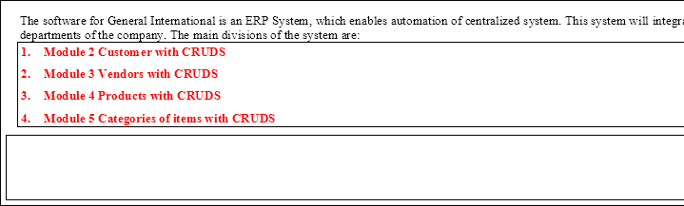Provide a brief, concise list of what the project is to accomplish.

## Success Factors:

List factors that will be used to determine the success of the project.

1. Complete deployment of all 4 modules
2. Smooth integration between all systems
3. A Tested Product

## Project Dependencies/Constraints:

1. Project completion is expected in less than 3.5 months duration
2. All requirements will be 100% available during requirement phase
3. Maximum team strength 4,
4. Average loading = 4 ,
5. 16(4+4+4+4) = E **<Write only one after calculating from COCOMO model>**

## Project Tradeoff Matrix & Status Summary

|  |  |  |
| --- | --- | --- |
| **Schedule/Time** | **Scope/ Modules** | **Resources/Effort/People** |
| CONSTRAINED | CONSTRAINED  / **ACCEPTED** | CONSTRAINED / Need to be **IMPROVED** (need reduction) / ACCEPTED  (Cocomo **Effort = 10 -15** not acceptable our constraint is max **4 members in 3 months**) |
|  |  | E = 16, S = 7.182, per month 2 persons, 3 months 5 to 6 persons = **est 7 person** |

Identify variable to be CONSTRAINED, IMPROVED, ACCEPTED

## Comments:

**Accepted**

## Project Organization(fizza)

*Provide an organization chart that defines the person responsible for at least the following functions: project manager, development manager, quality assurance, and configuration management.*

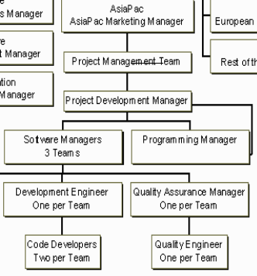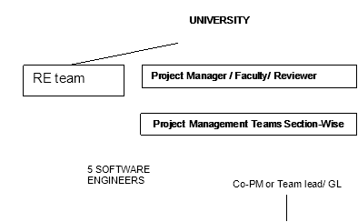

***SDLC Process Model:***

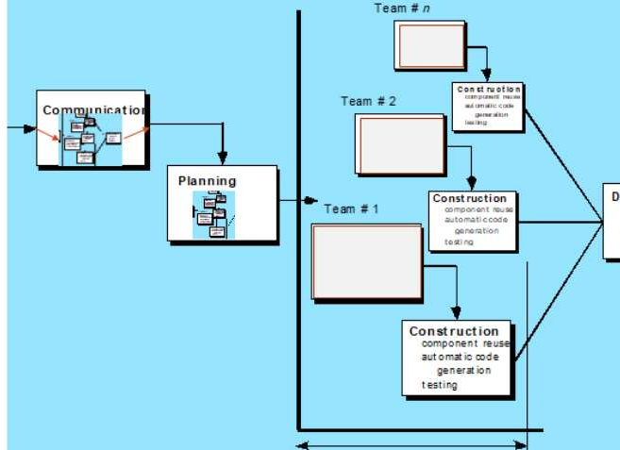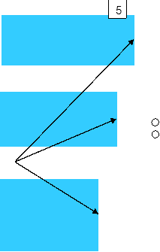

## Activity List (Work Breakdown Structure)(aqsa)

|  |  |  |  |  |  |  |  |  |  |  |
| --- | --- | --- | --- | --- | --- | --- | --- | --- | --- | --- |
| **B) B) Unadjusted Function Point Value calculation** | | | | | | | | | | |
| **Definition of Complexities:** Your Transactions which are derived from only from 1 Table are to be categorized as Low and if they are derive from 2 tables they can be categorized in Mid-level complexity, and in case of >= 3 they will be placed under High level of complexity. | | | | | | | | | | |
|  | Count for | Multiplier | V1 | Count for | Multiplier | V2 | Count for | Multiplier | V3 | Category |
| screens of | Low level | = | screens of | Mid-level | = | screens of | High-level | = | wise sum |
| Low level | complexity | C | Mid-level | complexity | C | High-level | complexity | C | V1+V2+V3 |
| complexity | (M) | * | complexity | (M) | * | complexity | (M) | * |  |
| (C) |  | M | (C) |  | M | (C) |  | M |  |
| EI | 3 | 3 | 9 | 1 | 4 | 4 |  | 6 | - | 13 |
| EO | 3 | 4 | 12 | 1 | 5 | 5 |  | 7 | - | 17 |
| EQ | 3 | 3 | 9 |  | 7 | - | 1 | 6 | 6 | 15 |
| ILF | 3 | 7 | 21 | 1 | 0 | 0 |  | 15 | - | 21 |
| ELF | 0 | 5 | 0 |  | 7 | 0 | 1 | 10 | 10 | 10 |
| **Unadjusted Function Point Value =** | | | | | | | | | | **76** |

Provide an activity list (work breakdown structure) that describes each task required by the project, with a reference to the statement of work. For large projects, work packages might be included that describe in detail how specific tasks will be completed by specific project teams. These work packages describe required schedule, identify requirements to be completed and describe specific work to be performed

1. **First Estimating FP then from it E and S. <Correctly Re calculate for your Project>**

|  |  |  |  |  |  |  |  |  |  |  |  |  |
| --- | --- | --- | --- | --- | --- | --- | --- | --- | --- | --- | --- | --- |
| **Software Size Estimation using Function Point Method** | | | | | | | | | | | | |
|  | | | | | | | | | | | | |
|  | **A) A) Detail of 5 Transaction Types, at most 5 under each category** | | | | | | | | | |  | |
|  |  | Write down exact Screen or Forms names, or Tables, or Reports name for each count value. | | | | | | | | |
|  | EI | 1. | user | 2. M2 | 3. M3 | 4 | M4 |  | 5. M5 |  |
|  | EO | 1. | user | 2. M2 | 3. M3 | 4 | M4 |  | 5. M5 |  |
|  | EQ | 1. | user | 2. M2 | 3. M3 | 4 | M4 |  | 5. M5 |  |
|  | ILF | 1. | user | 2. M2 | 3. M3 | 4 | M4 |  | 5. M5 |  |
|  | ELF | 1. | - | 2. - | 3. - |  |  | 4. | - | 5. - |
|  | | | | | | | | | | | | |
|  | | | | | | | | | | | | |
|  | **C) Value Adjustment Factor (VAF) calculation** | | | | | | | | | | |  |

|  |  |  |  |  |  |  |  |  |
| --- | --- | --- | --- | --- | --- | --- | --- | --- |
|  | **Note:** Calculate Value Adjustment Factor, where any 5 "General System Characteristics (GSC) must have a value above  2. Also show respect Quality Characteristic mapping of these 5 factors. | | | | | | |  |
|  |  | | Quality Characteristic | Weight (0-5) |  | Quality Characteristic | Weight (0-5) |  |
|  | 1. | | Data Communication | 4 | 8. | Online Update | 0 |  |
|  | 2. | | Distributed Data Processing | 3 | 9. | Complex Processing | 2 |  |
|  | 3. | | Performance | 3 | 10. | Reusability | 1 |  |
|  | 4. | | Heavily used Configuration | 1 | 11. | Installation Ease | 0 |  |
|  | 5. | | Transaction Rate | 5 | 12. | Operational Ease | 3 |  |
|  | 6. | | Online Data Entry | 3 | 13. | Multiple Sites | 0 |  |
|  | 7. | | End User Efficiency | 2 | 14. | Facilitate Change | 1 |  |
|  | **Value Adjustment Factor (VAF) = 28** | | | | | | |  |
|  | | | | | | | | |
| **D) Technology Complexity Factor calculation**  TCF = 0.65 + (VAF * 0.01)  = 0.65 +(28*0.01)  = 0.93 | | | | | | | | |
| **E) Adjusted Function Point Value (AFPV) or Function Point Value (FP) Calculation**  AFPV = _ Unadjusted Function Point * TCF  = 76 * 0.93  = 70.68 | | | | | | | | |
| **F) Conversion of AFPV in to LOC Size metric**  the number of LOCs per FP for **C# language 54** and check other languages from [https://www.qsm.com/resources/function-](https://www.qsm.com/resources/function-point-languages-table) [point-languages-table,](https://www.qsm.com/resources/function-point-languages-table) **ASP 51** and **VB.net 52, python 48**  Project Size in LOC = AFPV * LOC/FP  Project Size in LOC = 70.68 * 54 = 3816.72 LOC | | | | | | | | |
| **G)** Software Size: 3816.72  Software Size for COCOMO: 3.816 **KLOC**  Software Type: **Business**/ Utility/Embedded  Model Mode: Cocomo I – Basic – **ORGANIC (0 – 50 KLOC)** / Semi detached/ Embedded | | | | | | | | |
| a) a) **Effort Estimation:** Equation  3.0 * 3.816 ^ 1.12 **= E = 13 persons month** | | | | | | | | |
| b) b) **Schedule Estimation:** Equation 2.5 * E ^ 0.35 months **= S = 6 months** | | | | | | | | |
|  | c) c) | **Productivity Estimation:** Equation | | |  |  |  |  |

|  |  |
| --- | --- |
| Loc/E = 293.5 | |
| d) | d) **Average Loading Estimation:** Equation E/S =2 |
| e) | e) **Average Salary of Technical Staff (AS):** Equation Assume = 50,000 RS |
| f) | f) **Cost for Salary (Cs):** Equation E * Avg salary = 650,000 |
| g) | g) **Budgeted Cost of Project (Cb):** Equation Cs + Cs * X% = 975,000 |

1. **Calculate the phase-wise percentage distribution wise E and S values as given in detailed COCOMO detailed model.**

|  |  |  |  |  |  |  |
| --- | --- | --- | --- | --- | --- | --- |
| **H) Distribution of Effort and Schedule among Different phases of SDLC** | | | | | | |
| **E = 13 S = 6** | | | | | | |
| **Plan and Requirement (E | S)** | | **Modeling / System Design & Detailed Design (E | S)** | | **Module Coding and Unit Testing (E | S)** | | **Integration & D** |
| 0.06 * 13 = 0.78 | 0.10 * 6 = 0.6 | (0.16+0.26) * 13 =5.46 | (0.19+0.24) 6  =2.58 | 0.42 * 13 =5.46 | 0.39 * 6 =2.34 | 0.16 * 13 =2.08 |

1. **Now adding percentage distribution as given in detailed COCOMO model in the WBS phase-wise. <Write exact E/S values after multiplying with distribution percentages>(fizza)**

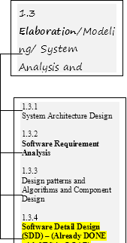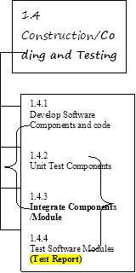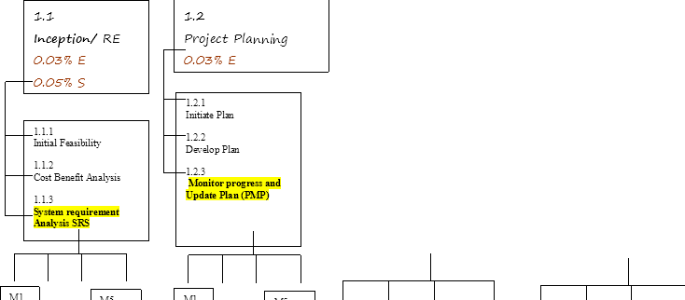



**Now convert above WBS contents in a Tabular format in order to make a GANTT CHART. <Complete>**

**22 days are taken from COCOMO detailed model’s Schedule Distribution done in Class for Project Planning and Requirement Engineering Phase. Where 40% of 22 goes in RE and 60% in Planning.(aqsa)**

**Activit Activity Name y #**

**Activity Name Description**

**# of Day s**

**Start Date**

**RE**

**Requirement Engineering**

**6-75 8/2/2022**

**Dependenc y on previous tasks**

**none**

**Mileston e**

**1.1**

**16/2/202**

**2**

* + 1. **Initial Feasibility**
    2. **Cost Benefit Analysis 1.1.3**

1.1.3.1

1

2

**3**

3

1.1.3.2

**System requirement Analysis SRS**

System requirement Analysis SRS **for Module 1**

System requirement Analysis SRS **for Module 2**

System requirement Analysis SRS **for Module 3**

System requirement Analysis SRS **for Module 4**

System requirement Analysis SRS **for Module 5**

Merging of all parallel Modules 1,2,3,4,5

Milestone (SRS) and Review meeting

**Project Planning**

3

1.1.3.3

3

1.1.3.4

3

1.1.3.5

3

1.1.3.6

1.1.4

**1.2**

**Project Management**

1-2

0

**14**

**Day**

**5/4/2022 1.1**

**20/4/202**

**2**

|  |  |  |  |  |  |  |
| --- | --- | --- | --- | --- | --- | --- |
|  |  | **Planning** | **s** |  |  |  |
| 1.2.1 | Planning For Module 1 |  |  |  |  |  |
| 1.2.2 | Planning For Module 2 |  |  |  |  |  |
| 1.2.3 | Planning For Module 3 |  |  |  |  |  |
| 1.2.4 | Planning For Module 4 |  |  |  |  |  |
| 1.2.5 | Planning For Module 5 |  |  |  |  |  |
| **1.3** | **Modeling** | **Done in SRS now ERD with Implementatio n** | **7**  **Day s** | **21/4/202**  **2** | **1.2** | **26/4/202**  **2** |
| 1.3.1 | Modeling For Module 1 |  |  |  |  |  |
| 1.3.2 | Modeling For Module 2 |  |  |  |  |  |
| 1.3.3 | Modeling For Module 3 |  |  |  |  |  |
| 1.3.4 | Modeling For Module 4 |  |  |  |  |  |
| 1.3.5 | Modeling For Module 5 |  |  |  |  |  |
| **1.4** | **Implementation and Testing** | **Database and Code, Test Report** | **10**  **Day s** | **27/4/202**  **2** | **1.3** | **6/5/2022** |
| 1.4.1 | Imp & Testing For Module 1 |  |  |  |  |  |
| 1.4.2 | Imp & Testing Module 2 |  |  |  |  |  |
| 1.4.3 | Imp & Testing For Module 3 |  |  |  |  |  |
| 1.4.4 | Imp & Testing For Module 4 |  |  |  |  |  |
| 1.4.5 | Imp & Testing For Module 5 |  |  |  |  |  |
| **1.5** | **Deployment/Dem o** | **Demo and Report** | **10**  **Day s** | **10/5/202**  **2** | **1.4** | **20/5/202**  **2** |
| 1.5.1 |  |  |  |  |  |  |
| 1.5.2 |  |  |  |  |  |  |
| 1.5.3 |  |  |  |  |  |  |
| 1.5.4 |  |  |  |  |  |  |
| 1.5.5 |  |  |  |  |  |  |

## Work Product Identification (alina)

Provide a list of all deliverables required by the project, the date due and the person responsible for the deliverable. Pick Last activities from each phase they are deliverables. **<Complete>**

|  |  |  |  |
| --- | --- | --- | --- |
| ***Deliverable Name*** | ***Due Date*** | ***Date Delivered*** | ***Point of Contact*** |
| SRS by Member 1 (AQSA) | 19/03/2022 | 5/03/2022 | 10609 |
| SRS by Member 2 (ALINA) | 19/03/2022 | 5/03/2022 | 10611 |
| SRS by Member 3 (HAFSA) | 19/03/2022 | 5/03/2022 | 10420 |
| SRS by Member 4 (FIZZA) | 19/03/2022 | 5/03/2022 | 10481 |
|  |  |  |  |
| PMP by Member 1 (AQSA) | 26/04/2022 | 26/04/2022 | 10609 |
| PMP by Member 2 (ALINA) | 26/04/2022 | 26/04/2022 | 10611 |
| PMP by Member 3 (HAFSA) | 26/04/2022 | 26/04/2022 | 10420 |
| PMP by Member 4 (FIZZA) | 26/04/2022 | 26/04/2022 | 10481 |
|  |  |  |  |
| Design (DB+GUI) by (AQSA) | 17/05/2022 | 10/05/2022 | 10609 |
| Design (DB+GUI) by (ALINA) | 17/05/2022 | 10/05/2022 | 10611 |
| Design (DB+GUI) by (HAFSA) | 17/05/2022 | 10/05/2022 | 10420 |
| Design (DB+GUI) by (FIZZA) | 17/05/2022 | 10/05/2022 | 10481 |
|  |  |  |  |

## SCHEDULE

Provide the project schedule, using a **Gantt chart**. The schedule must include milestones, task dependencies (predecessors), task duration, **work product delivery** dates, quality milestones (reviews/**audits**/inspections), configuration management milestones, and action items (with deadlines and responsibilities). (in order to keep the project (T | C |S) in CONTROLL.

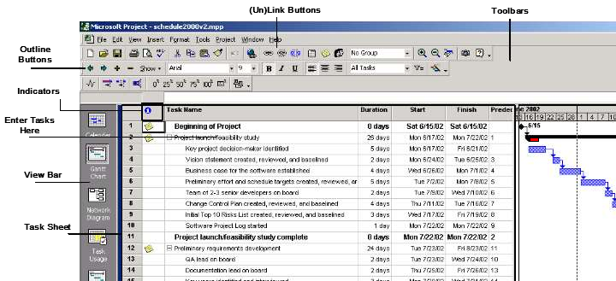**<MUST IMPLEMENT GANTT CHART ON ANY SOFTWARE OR WEBAPPLICATION>**

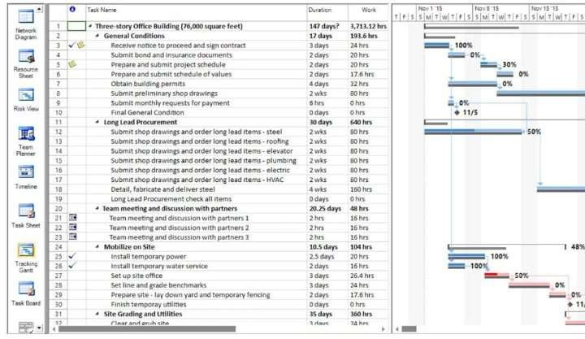**<Add % completion in it after submission of PMP expected on 18/12/2021, and also paste screen capture of Tracking Gantt Chart view>**

## Estimated Cost at Completion

Provide an estimated cost at completion, which is an assessment of the total effort at completion of the contract.

|  |  |  |  |  |  |  |
| --- | --- | --- | --- | --- | --- | --- |
| **Analysis in Hours / Cost** | | | | | | |
| **WBS No.** | **Activity Description** | **Budget Hours**  **B** | **Actual Hours**  **A** | **Est. to Complete the remaining work – milestone-wise**  **ETC B - A**  **EAC – A** | **Est. @ Completion**  **EAC**  **A + ETC** | **Variance (+ = V = (A-B/A)** |
| **1st** |  | **8** | **40** | **60 – 40 = 20** | **40 + 20 = 60** | **(-1 -- 0 -- +1)** |
| **milestone** | **working days** |  |  |  | **( 40 - 60)/ 40** |
|  | **60** |  |  |  | **Under the bu 50V** |
|  |  |  |  |  | **60-60 / 60 = 0** |
|  |  |  |  |  | **100% comple** |
|  |  |  |  |  | **(70 – 60)/70 =** |
|  |  |  |  |  | **Ahead of bud** |
|  |  |  |  |  | **14V** |
| **2nd** |  | **60** | **40** | **60 – 40 = 20** | **40 + 20 = 60** | **( 40-60)/ 40 =** |
| **milestone** |  |  |  |  | **Under the bu** |
|  |  |  |  |  | **60-60 / 60 = 0** |
|  |  |  |  |  | **100% comple** |
|  |  |  |  |  | **(70 – 60)/70 =** |
|  |  |  |  |  | **Ahead of bud** |

|  |  |  |  |  |  |  |
| --- | --- | --- | --- | --- | --- | --- |
|  |  |  |  |  |  |  |
|  |  |  |  |  | **%remaining** |  |

## Resource Loading Profiles – Staffing(alina)

Provide a staffing plan that shows the number of personnel, by type, that will be required on the project on a monthly basis.

|  |  |  |  |  |  |  |
| --- | --- | --- | --- | --- | --- | --- |
| **Resource Loading Profiles** | | | | | | |
| **E = 13 S = 6**  Avg Loading = 2 person per month  Since loading gives same value of effort for all months, therefore, we have used Detailed COCOMO’s Effort di already done in part 5.2 | | | | | | |
| **Plan and Requirement** | | **Modeling / System Design & Detailed Design** | | **Module Coding and Unit Testing** | | **I** |
| 0.06 * E = **0.78** | 0.10 * S = **0.6** | (0.16+0.26) *  E = 5.46 | (0.19+0.24)  S = 2.58 | 0.42 * E =  5.46 | 0.39 * S =  2.34 | 0.16 *  2.08 |
| **Designation:** PM, ~~BA, Domain~~ ~~Expert~~ = 0.96 (Aqsa Hussain) | | BA, Analyst, Domain Expert = (Alina Fahim) | | Coders and Testers (Hafsa Kanwal) | | Senio Ishaq) |
| **Job Description:** Assisting in building SPMP, SRS and prototype, as well as doing the necessary requirement and risk analysis for the project | | Job Description: Assisting in building SPMP, SRS and prototype, as well as doing the necessary requirement and risk analysis for the project | | Job Description: assisting in building SPMP, SRS and prototype, as well as doing the necessary requirement and risk analysis for the project | | Job D Assist SPMP  protot doing requir analys |
| **Contact**  **information:** [haqsa2216@gmail.com,](mailto:haqsa2216@gmail.com) 03172831696 | | Contact information: [alinafahim761@gmail.com,](mailto:alinafahim761@gmail.com) 03162512299 | | Contact information: [mughalkanwal8@gmail.com,](mailto:mughalkanwal8@gmail.com) 03333555784 | | Conta fizzai 03343 |

# 11. Risk Identification(fizza)

|  |  |
| --- | --- |
| **Top 10 Risk Items** | |
| **Risk Items** | **Risk Management Techniques** |
| Personnel Shortfalls | Staffing with top talent, job matching; team building; morale building; cross train key people |
| Unrealistic schedules and budgets | Detailed, multi-source cost and schedule estimation; design to cost; incremental d software reuse; requirement scrubbing |
| Developing the wrong software functions | Organizational analysis; mission analysis; ops-concept formulation; user surveys; users' manuals |
| Developing the wrong user interface | Task analysis; prototyping; scenarios; user characterization (functionality, style, |
| Gold Plating | Requirement scrubbing; prototyping; cost-benefit analysis; design to cost |
| Continuing stream of requirement changes | High change threshold; information hiding; incremental development (defer chan increments) |
| Shortfalls in externally furnished components | Benchmarking; inspections; reference checking; compatibility analysis |
| Shortfalls in externally performed tasks | Reference checking; pre-award audits; award-fee contracts; competitive design o building |
| Real-time performance shortfalls | Simulation; benchmarking; modeling; prototyping; instrumentation; tuning |
| Straining computer-science | Technical analysis; cost-benefit analysis; prototyping; reference checking |

Provide a description of all risks identified for the project. A risk is anything that might detrimentally affect the successful completion of the project if left unaddressed. The contractual, management, and technical risks associated should be **identified** and **assessed** as to the **probability of the risk occurring**, the **cost to correct** if the risk occurs, the impact of the risk on the project, and the suggested mitigation activities and cost of mitigation.

**Risk Worksheet**

**Risk Management Steps:**

|  |  |
| --- | --- |
| 1 | Identify the project’s top10 risk items |
| 2 | Present a plan for resolving each risk item |
| 3 | Update list of top risk items, plan, and results monthly |
| 4 | Highlight risk-item status in monthly project reviews. Compare with previous month’s ranking status |
| 5 | Initiate appropriate corrective actions |

**Potential Risk**

|  |  |
| --- | --- |
| capabilities |  |

**Risk Monitoring**

**Risk Management and**

**Risk Exposure**

**Prioriti**

**Preventive measures**

**mitigation**

**= Probability of Risk**

**Till nex**

**Occurrence * Cost of Review**

1. **Size of the software** being very large and larger number of **users** than planned due to using eval SDLC and no confirmation of Requirements in RE phase. (Fp→Loc→Effort)
2. The software not being accepted by the CRM
3. **Cost factor** involved in this project
4. **Customer requirements may change**
5. **Technology** will not meet **expectation**
6. **Lack of training on tools and staff** being inexperienced
7. The **prototype** not being **delivered on time**

Reviewing **constant feedbacks from the customers** in **project meetings**

**Response from the CRM,** reviewed on every **project meeting**

Reviewing **reports on expenditure and other cost related** to the estimated cost in the **SPMP**

**CRM participation in design process** and reviewing feedback information in **group meetings**

Constantly reviewing **project progress reports** by Project Development Manager and software managers

Reviewing **progress report** by software managers to determine the **status of the project**

Constant reviews **among team members** to ensure **continuous progress** on the prototype

**Being flexible** in the **software design** to accommodate the necessary changes

Early and **intensive interaction with the customer** for the success of project.

**Have additional funding** allocated for it in advance and using it in case of emergencies.

**A new prototype** will replace the previous one to **accommodate the change**

**Exploring alternatives** for the outdated technologies

**Providing adequate training** that is necessary for the **completion of the project**

**Setting deadline** before the **actual time** for submission of the project

**Risk**

Cost * Probability of Risk Occurrence

= Salary for 2 programmer for 1

month * **0.8**

= 60000 *0.8 | 0.4

=48000 | 24000

* 1. ***Configuration Management Plan(hafsa)***

Provide a configuration management plan that defines the person responsible for project configuration management, the procedures that will be used, the planned configuration items, planned release dates for configuration items, and resources required to conduct CM.

*CCB members: Aqsa Hussain , Alina Fahim, Hafsa Kanwal, Fizza Ishaq*

Configuration Items: Ensure that CM is implemented throughout the project’s life cycle.

|  |  |  |
| --- | --- | --- |
| No. | Item | Comments |
| 1. | **Proposal** | **28th Feb, 2022: Baseline 1** |
| 2. | **SRS** | **6th March, 2022 Baseline 1** |
| 3. | **PMP** | **25th April, 2022: Baseline** |

Ensure that project has a repository for storing configuration items and associated CM records. Briefly describe.

**Git hub repository**

## Quality Plan(alina)

Provide a quality plan that defines the person responsible for project quality assurance, the procedures that will be used and resources required to conduct quality assurance.

*QA Manager and Staff:*

*Manager: Aqsa Hussain that responsible for project quality Staff: Alina Fahim, Hafsa Kanwal, Fizza Ishaq*

**Planned Quality Event:** Ensure that QA is implemented throughout the project’s life cycle.

Dates include QA audits and reviews, design walkthroughs and other project activities that QA staff will participate in.

|  |  |  |
| --- | --- | --- |
| No. | Item | Comments |
| 1. | **Proposal (28th Feb, 2022)** | **This document is audit, design, review and walkthrough all the QA staff** |
| 2. | **SRS (6th March,2022)** | **This document is audit, review and walkthrough all the QA staff** |
| 3. | **PMP (25th april,2022)** | **This document is audit, design, review and walkthrough all the QA staff** |

Ensure that project has a repository for storing configuration items and associated QA records. Ensure that QA audits the baselines and CM activities on a regular basis.